# PROJECT DESIGN

## Problem Solution Fit

|  |  |
| --- | --- |
| Date | 10 April 2025 |
| Team ID | SWTID1742907331 |
| Project Name | MaitriLok : Social Media App |
| Maximum Marks | 2 Marks |

## 

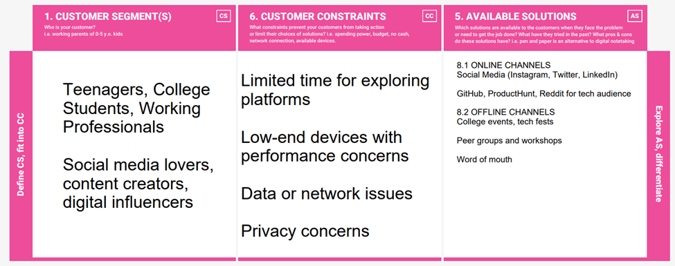

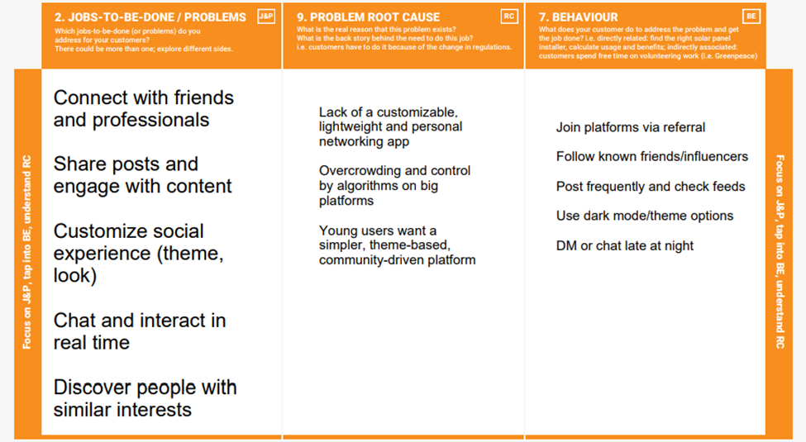

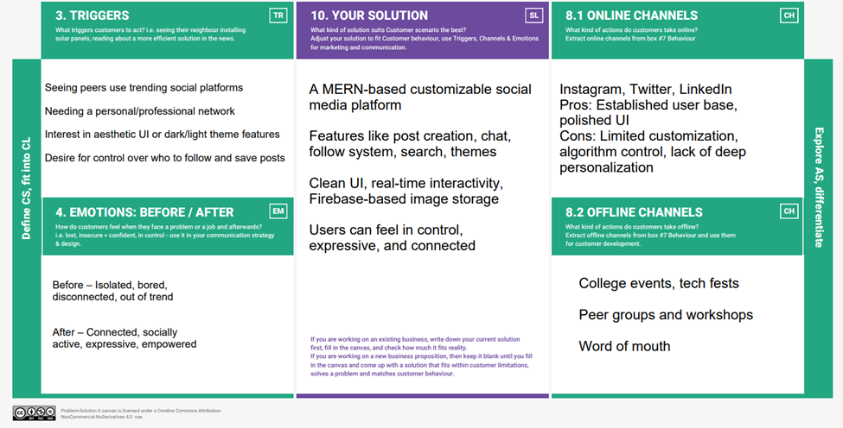

## 

## Proposed Solution

|  |  |  |
| --- | --- | --- |
| **S.No.** | **Parameter** | **Description** |
| 1 | Problem Statement (Problem to be solved) | Existing social platforms often lack meaningful user engagement, personalized experiences, and simplified interaction mechanisms. There is limited control over content discovery, network building, and theming. |
| 2 | Idea / Solution Description | Maitrilok is a MERN-stack based social media platform with user registration/login, feed with post creation/edit/delete/like/comment/save, search functionality, theme customization, real-time chat, and a dynamic "My Network" section showing latest posts from followed users. |
| 3 | Novelty / Uniqueness | Includes real-time chat between mutual followers, theme switcher with custom color palettes, personalized network feed, role-based content management, and smooth UX across user actions like post saving, commenting, and following. |
| 4 | Social Impact / Customer Satisfaction | Encourages digital friendships and communities with better personalization, promotes safe and respectful interactions, and boosts satisfaction through custom UI and intelligent network curation. |
| 5 | Business Model (Revenue Model) | Freemium model with ad support, premium features like profile highlights and visibility boosts, sponsored posts, and partnership opportunities with influencers and local communities. |
| 6 | Scalability of the Solution | Built on scalable cloud infrastructure (MongoDB Atlas, Node.js backend), capable of supporting large user base, feature extensions like mobile app integration, multilingual support, and additional interaction modes (e.g., stories or video posts). |

## Solution Architecture

User

Login

Sign up

Profile

Feed

Chat

My Network

Navigation Bar

Theme Switcher

Search Bar

Post

# 